**GROUP 10**

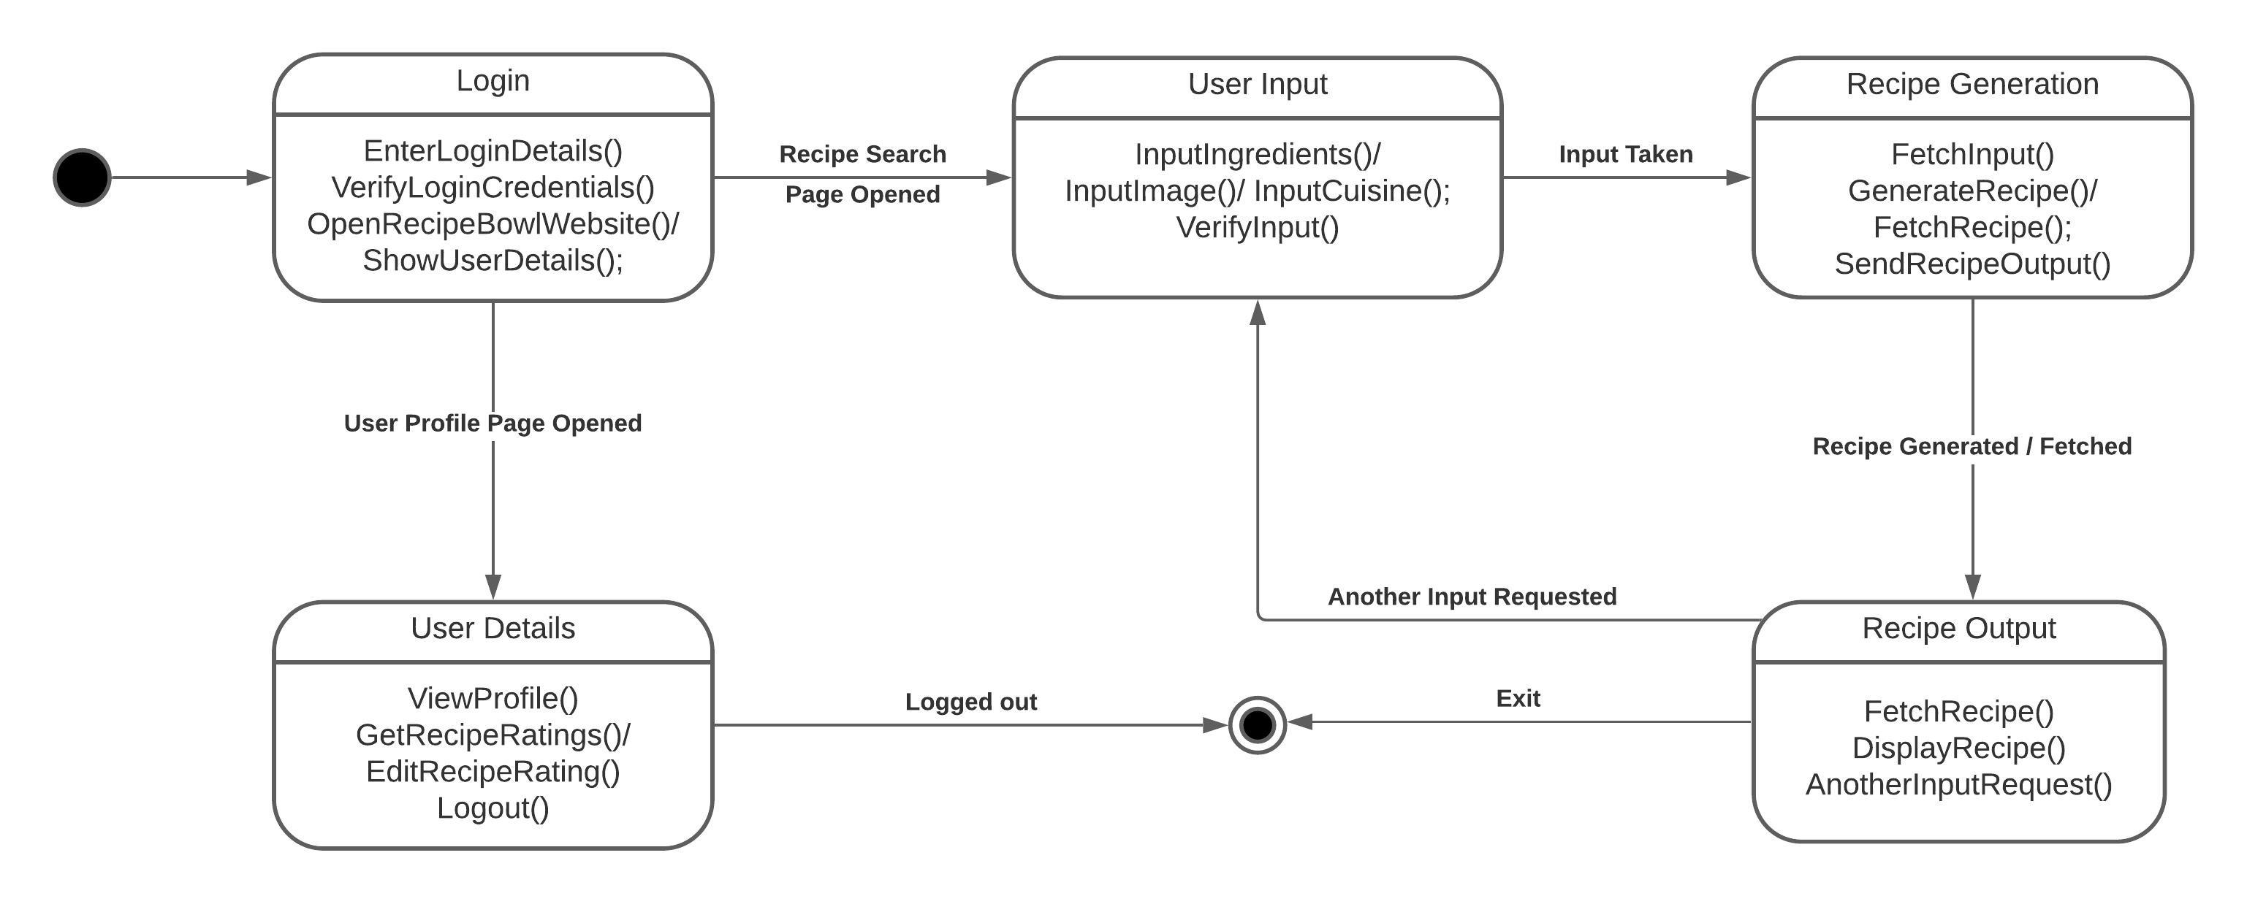**STATE CHART DIAGRAM:**

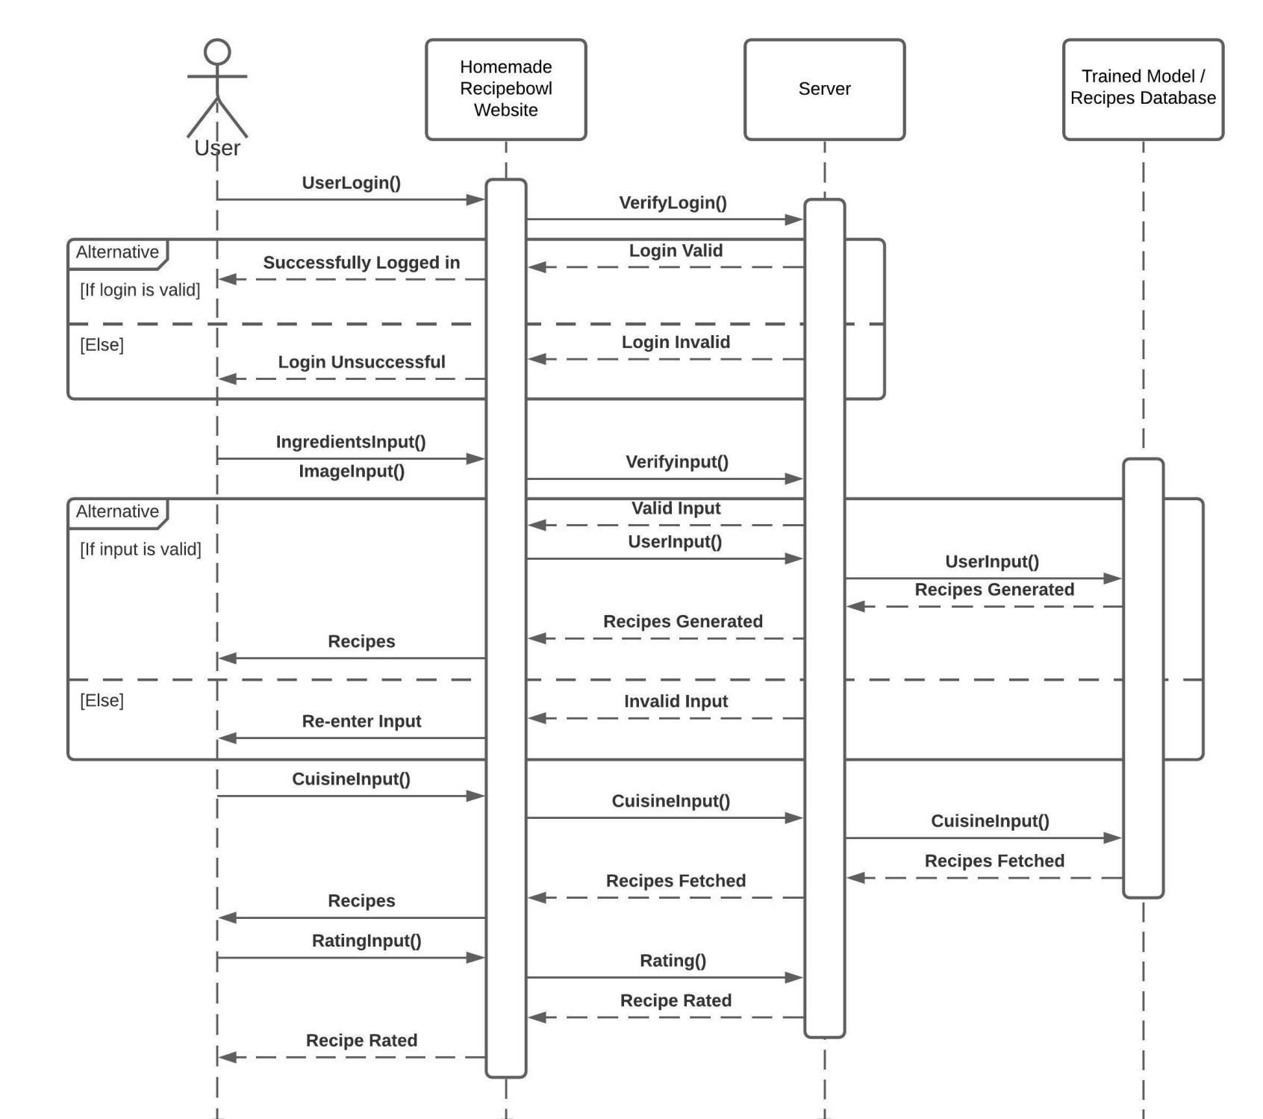**SEQUENCE DIAGRAM:**

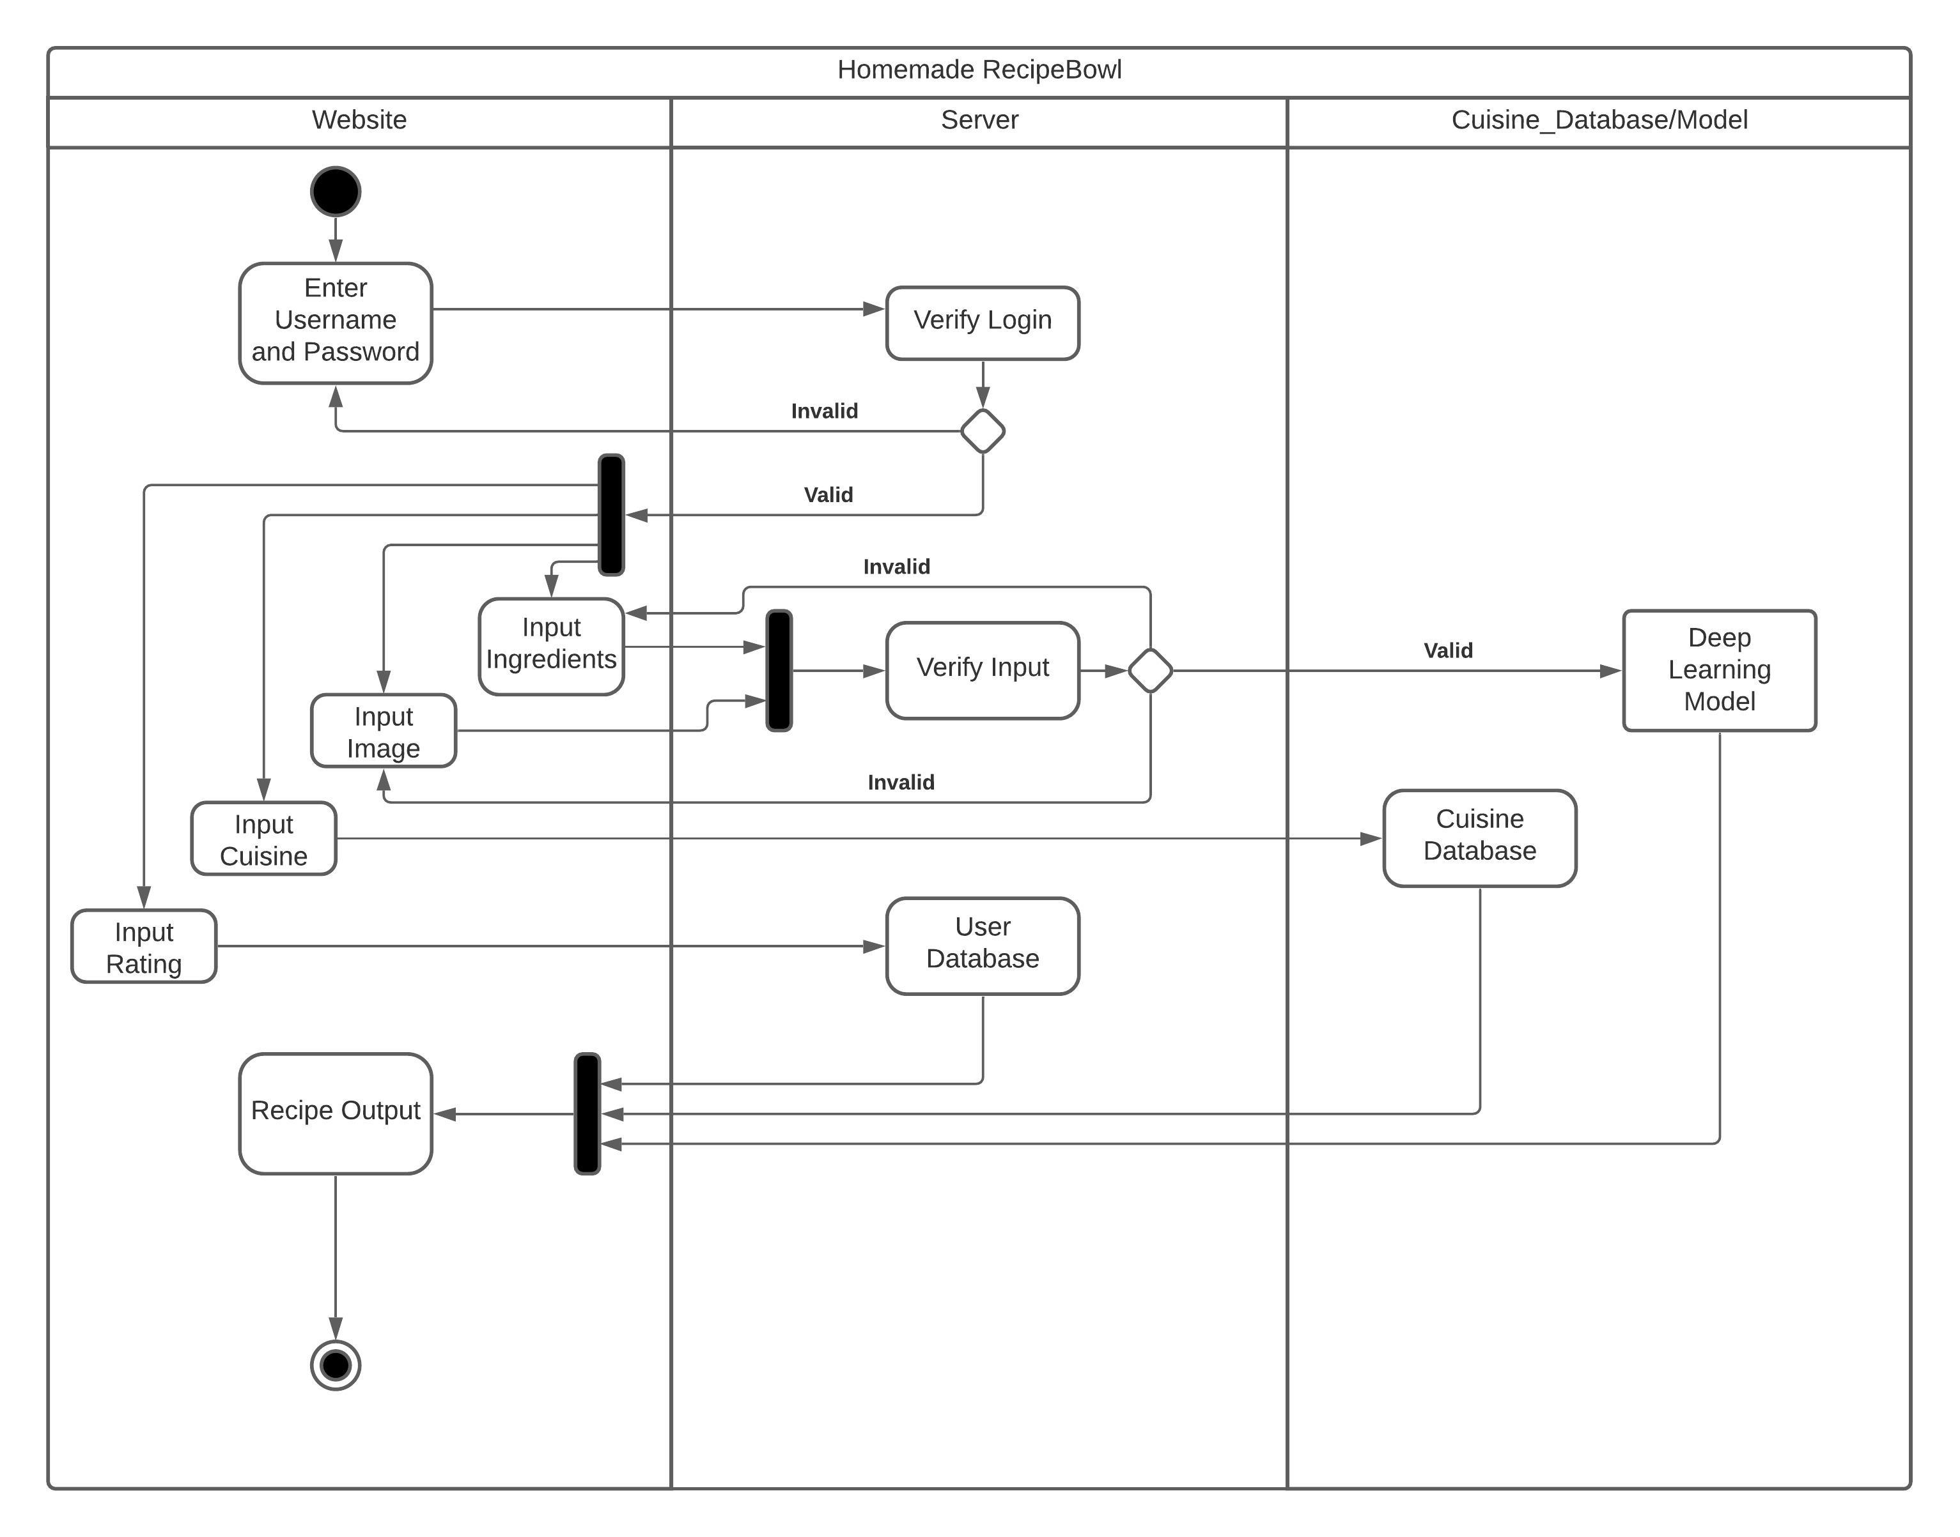**ACTIVITY DIAGRAM:**